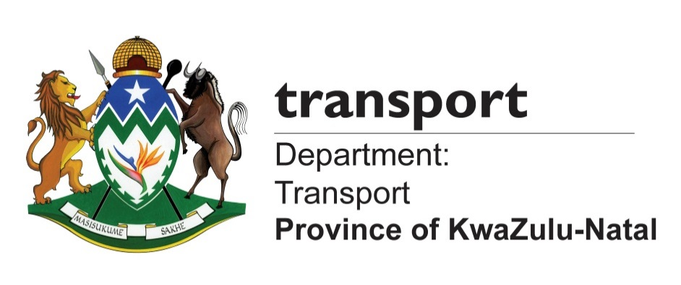

MEDIA ADVISORY

Monday, 29 January 2018

MEC KAUNDA TO QUELL SA/MOZAMBIQUE BORDER UNREST

The KwaZulu-Natal MEC for Transport, Community Safety and Liaison, Mr Mxolisi Kaunda, will be convening an urgent meeting with all stakeholders responsible for the management of the South African and Mozambique border post in Manguzi tomorrow.

The meeting follows an upsurge in incidents of car hijacking and arm robbery, which has led to community members organising a protest march to shut down the border gate of Kosi Bay last week.

Kaunda will be meeting with all government departments charged with the responsibility of improving the security along the border and assess the progress made in implementing programmes aimed at reducing cross-border crime.

After the meeting, Kaunda will address community members and update them about the progress and the interim security measures government has put in place to secure the area.
The meeting will take place as follows:

Venue: Tembe Traditional Court
Date: 30 June 2018
Time: 11H00

For more information contact Kwanele Ncalane on 0796995755 or Mluleki Mntungwa 0609741140
Ends.

Media contacts:
Mluleki Mtungwa 0609741140 mluleki.mtungwa@kzntransport.gov.za
Kwanele Ncalane: 072- 803 1462/ 079- 699 5755/ Kwanele.Ncalane@kzntransport.gov.za
Nathi Sukazi 081 018 0518/ Nathi.Sukazi@kzntransport.gov.za

Website: www.kzntransport.gov.za
Twitter: @KZNTransport
Facebook: www.facebook.com/kzntransport

